1.Logical Reasoning:
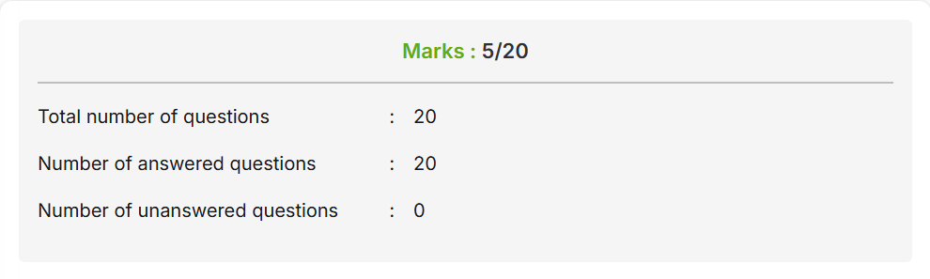
2.Verbal Ability:
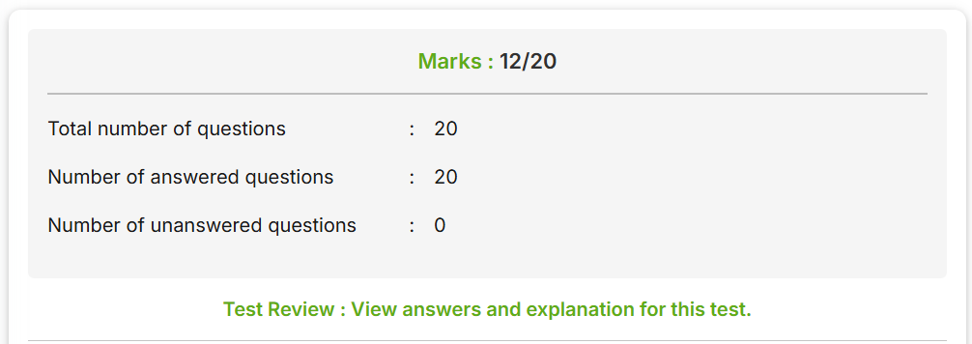
3.Non Verbal Reasoning:
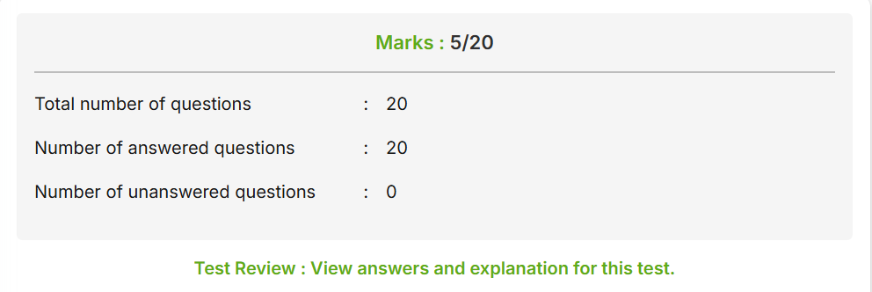
4.Data Interpretation
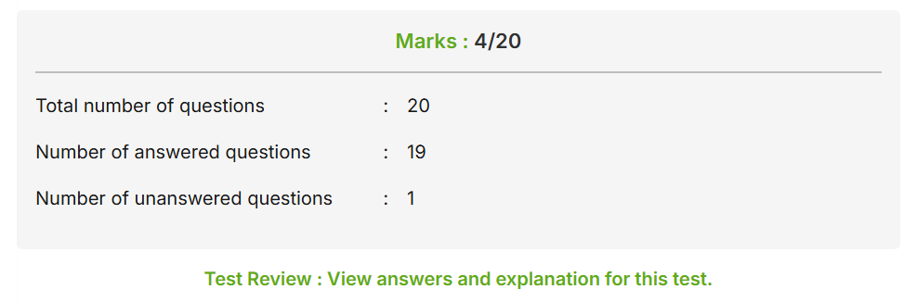
5.Aptitude: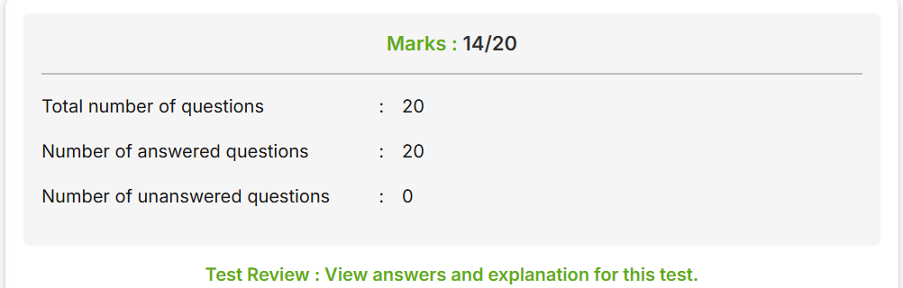
6.Verbal Reasoning:


